ELEC2004 Homework 2

By Samuel Allpass

Question 1)

56

0.080

56

56

56V

Thus, it took 80 milliseconds for the output voltage to equal 0.

Question 2)

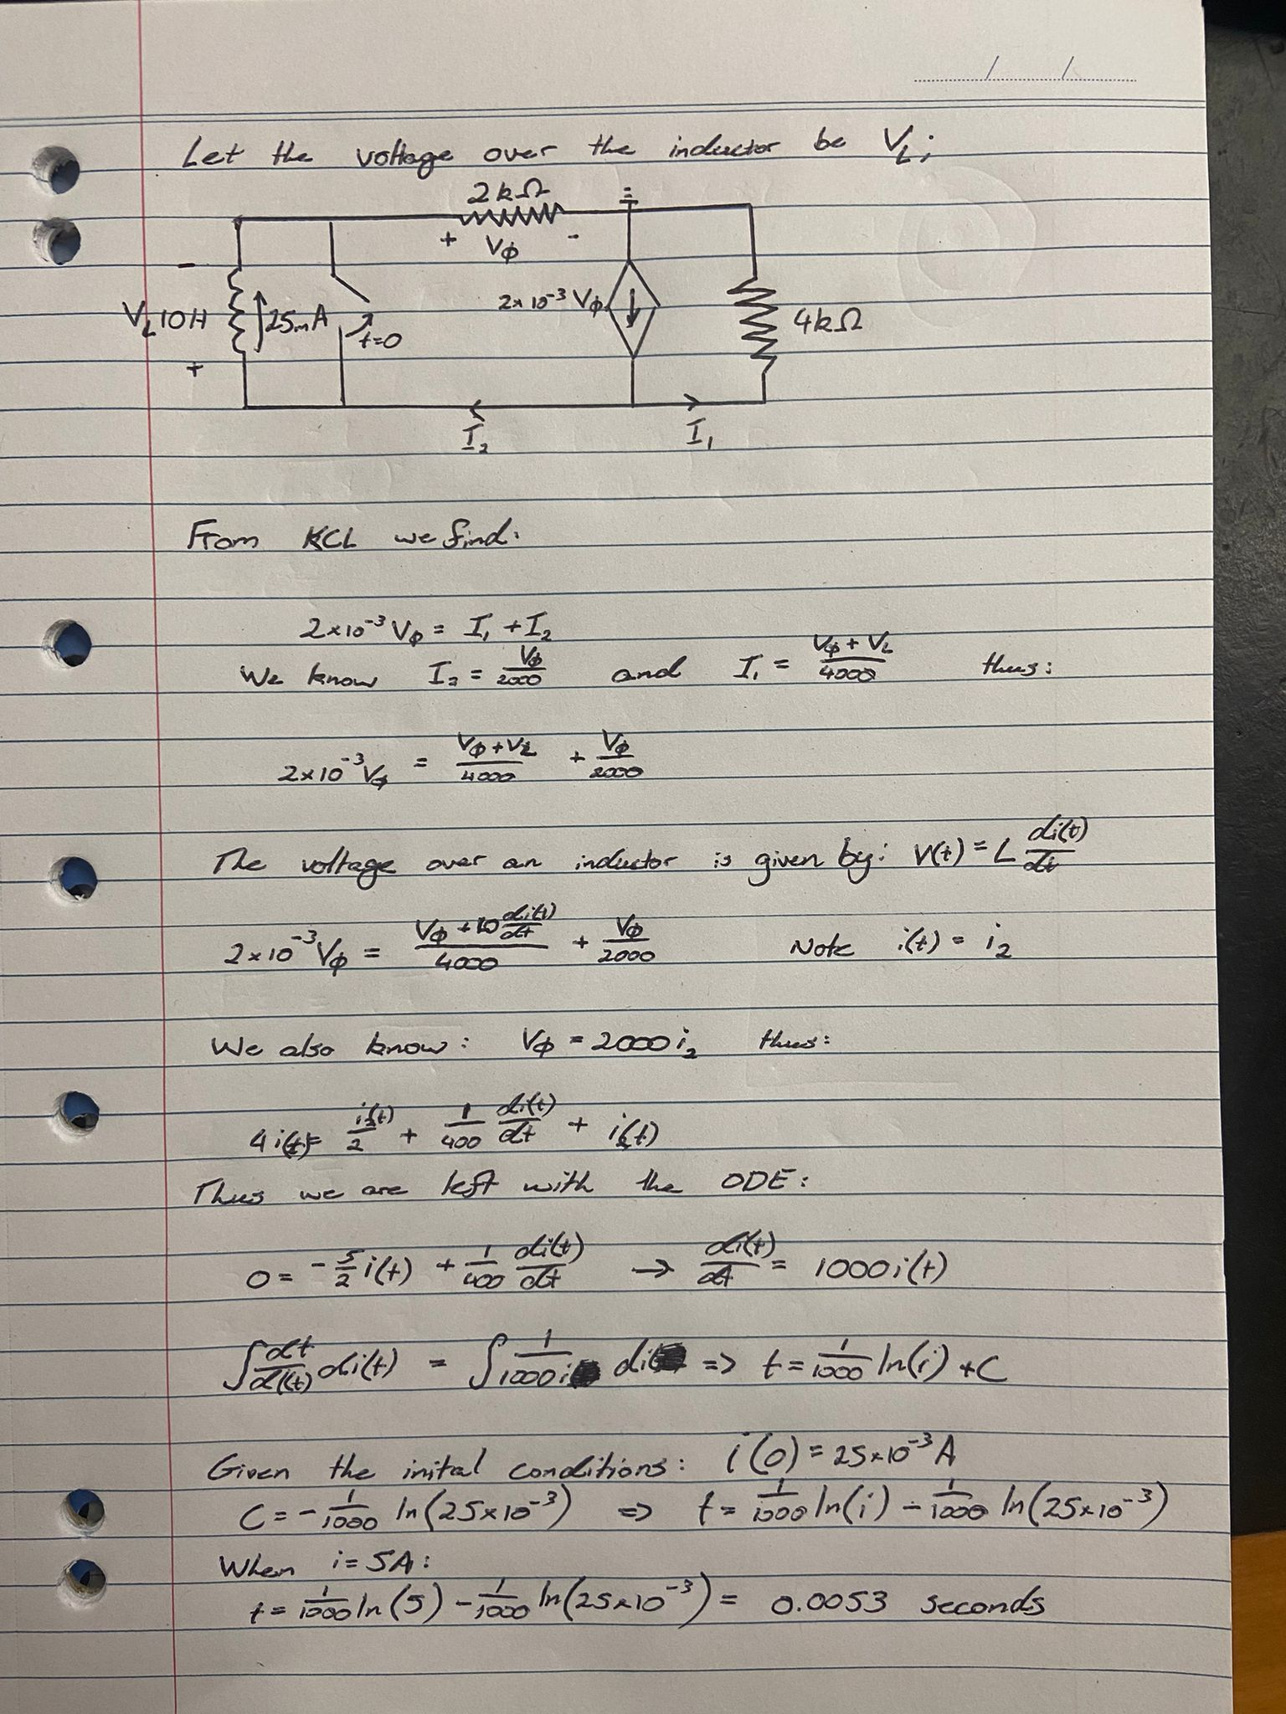

Thus, it took 0.0053 seconds (53 milliseconds) after the switch was opened for the inductor to malfunction at the 5A limit.